Revision Test 2
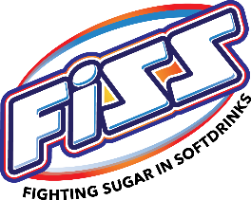

GROUP NAME:
CLASS:

Members:

- List examples of how the Breakfast Food companies make the cereal box
look healthier than it is:
__________________________ ___________________________
__________________________ ___________________________
__________________________ ___________________________

- What percentage (%) of Nutri Grain & Muesli Bars
is made up of SUGAR?

- What are some Healthier Low sugar food options we looked at in today’s class:
__________________________ ___________________________
__________________________ ___________________________
__________________________ ___________________________

- List as many foods and products that have added sugar.

____________________________________________________________
____________________________________________________________
____________________________________________________________
____________________________________________________________
____________________________________________________________
____________________________________________________________

- What are the 3 RULES: to choose food well?

- __________________________________

- __________________________________

- __________________________________

